1

Optimizing Cold Start Latency in Serverless Computing

N. Yaswanth, R. Rohan Chandra Department of Computer Science and Engineering

National Institute of Technology Karnataka Surathkal, Mangalore, India

Phone: +91-9676794131, +91-8639884378

[namburiyaswanth.221cs232@nitk.edu.in,](mailto:namburiyaswanth.221cs232@nitk.edu.in) [regulagaddarohanchandra.221cs241@nitk.edu.in](mailto:regulagaddarohanchandra.221cs241@nitk.edu.in)

***Abstract*—Serverless computing allows for great scalability and cost savings by abstracting infrastructure management. However, cold start latency—delays experienced when func- tions are activated after a period of inactivity—remains a significant challenge. This study describes a machine learning (ML) and Explainable AI (XAI)-driven architecture for predicting and mitigating cold starts via dynamic resource optimization. Our solution uses advanced AI models to pre- warm resources based on expected consumption patterns, effectively lowering cold start delays and improving sys- tem responsiveness. The use of XAI approaches increases transparency in decision-making and allows stakeholders to understand resource allocation procedures. Experimental results show a significant reduction in cold start latency, which leads to better overall system performance and user experience. This adaptive and intelligent technique provides a scalable solution for optimizing resource management in serverless systems while increasing confidence through explainability.**

1. Introduction
2. *Background*

The rise of digital technologies in the mid-twentieth century marked the beginning of an era where tradi- tional business models were reshaped by technological advancements. As industries increasingly relied on digital and network-based technologies, the need for scalable infrastructure solutions became evident. This shift paved the way for *cloud computing*, which introduced scalable, on-demand access to shared computing resources. Cloud computing models, including Infrastructure as a Service (IaaS), Platform as a Service (PaaS), and Software as a Service (SaaS), offered businesses an alternative to managing extensive hardware setups, thereby reducing operational costs and complexity [2], [4]. These models allowed enterprises to leverage virtualized infrastructure, managed platforms, and hosted applications to streamline operations, support growth, and enhance flexibility.

In 2014, *Amazon Web Services (AWS)* introduced the concept of *serverless computing* through AWS Lambda. This new cloud computing paradigm shifted the focus from managing infrastructure to focusing solely on code. Serverless computing abstracts infrastructure management completely, enabling developers to deploy and execute functions without the need to provision or manage servers manually. Platforms like AWS Lambda, Google Cloud Functions, and Microsoft Azure Functions automatically

allocate resources in response to user demands, simpli- fying the development process and improving scalability [12]. This design has made serverless computing a pre- ferred choice for applications with fluctuating workloads, such as event-driven applications and microservices.

Despite its advantages, serverless computing introduced unique challenges. One of the most critical is the *cold start* problem, which occurs when a serverless function is invoked after a period of inactivity. During a cold start, the serverless platform must allocate and initialize resources, such as containers or virtual environments, before executing the function. This initialization process can lead to delays, particularly in latency-sensitive appli- cations, as the function cannot start processing until all resources are ready. Cold starts are especially problematic for real-time applications where responsiveness is crucial, as these delays can degrade user experience and reduce the effectiveness of time-sensitive operations [12].

1. *Motivation*

While serverless computing offers notable benefits in terms of cost savings, scalability, and developer produc- tivity, the cold start problem remains a significant perfor- mance bottleneck. Cold starts introduce latency that can range from a few milliseconds to several seconds, depend- ing on factors such as function size, memory allocation, and platform-specific configuration [11]. This latency can pose a major challenge for applications requiring rapid responses, including healthcare monitoring systems that depend on real-time data, financial transaction systems with stringent latency requirements, and Internet of Things (IoT) applications where delayed responses can compro- mise system integrity.

The cold start issue arises primarily because serverless functions are designed to be *stateless*; resources are re- leased after each execution to reduce costs, meaning that a new container must be initialized for subsequent invoca- tions after a period of inactivity. Existing approaches, such as *container pre-warming*, involve keeping functions in a partially initialized state for a set period after execution, which can help reduce cold start delays [5]. However, pre-warming is often inefficient, as it can lead to wasted resources when containers remain idle during off-peak periods. This strategy may also increase operational costs, as platforms may continue to reserve resources that are not actively utilized.

To overcome these limitations, there is a pressing need for more *adaptive solutions* that can dynamically adjust resource allocation based on real-time function invoca- tion patterns. Ideally, these solutions should optimize resource usage without compromising performance, allow- ing serverless platforms to handle unpredictable workloads efficiently [11]. Such adaptive solutions would not only enhance response times but also reduce operational costs, providing a more robust serverless computing environment for high-demand applications.

1. *Objectives*

This chapter introduces a novel framework that em- ploys Machine Learning (ML) and Explainable AI (XAI) techniques to address the cold start problem in server- less computing environments. By integrating predictive models such as deep neural networks and Long Short- Term Memory (LSTM) networks, this framework aims to optimize the pre-warming of containers based on function invocation patterns [1]. This adaptive approach allows the system to anticipate periods of activity and proactively manage resources, reducing cold start occurrences and delays [13].

The specific objectives of this chapter are:

* + **To propose an adaptive machine learning ap- proach** that uses XAI techniques to enhance trans- parency and interpretability in serverless resource management. XAI helps stakeholders understand and trust the system’s resource allocation decisions, espe- cially in high-stakes applications where reliability is crucial [3].
  + **To develop methods for optimizing the idle con- tainer duration**, minimizing resource waste while ensuring readiness for incoming requests. By calcu- lating the optimal idle-container window based on historical invocation patterns, the framework can keep containers warm only when needed, thus achieving a balance between performance and cost [13].
  + **To evaluate the effectiveness of the proposed model** in comparison with traditional strategies such as static pre-warming. Through experimental analysis across different serverless platforms, this study demonstrates the model’s ability to reduce cold start latency, en- hance response times, and achieve higher resource efficiency [1], [3].

By achieving these objectives, this chapter aims to provide insights into how AI-driven solutions can enhance serverless computing performance, particularly in latency- sensitive and high-demand environments. This framework not only contributes to the efficiency of serverless plat- forms but also addresses the need for transparent and cost- effective resource management strategies that can adapt to evolving application requirements [3].

1. Cloud Computing Overview
2. *Service Models*

Cloud computing provides various service models that offer different levels of control, flexibility, and abstraction [9]. These models allow businesses and developers to

choose the level of management and customization needed for their applications. The primary cloud service models include:

* 1. **Infrastructure as a Service (IaaS):** IaaS is the most fundamental cloud service model, providing virtu- alized computing resources over the internet. With IaaS, organizations can provision and manage virtual machines, storage, and networking resources, giving them full control over the underlying infrastructure [10]. This model is highly customizable, allowing businesses to configure resources according to their specific requirements. IaaS is particularly useful for organizations that need to manage complex applications or require extensive control over their infrastructure. Examples of IaaS providers include Amazon Web Services (AWS), Microsoft Azure, and Google Cloud Platform (GCP), which allow users to scale resources up or down based on demand and avoid the costs associated with purchasing physical hardware.
  2. **Platform as a Service (PaaS):** PaaS abstracts much of the underlying infrastructure, providing a man- aged environment for application development and deployment [8]. In a PaaS environment, developers focus on writing code and building application func- tionality while the platform handles infrastructure management tasks, such as resource allocation, scal- ing, and load balancing. This model allows develop- ers to concentrate on application logic and features without needing to worry about the underlying hard- ware or software configurations. PaaS environments typically include tools for development, testing, and deployment, making it easier for developers to bring applications to market faster [7]. Examples of PaaS include Google App Engine, Microsoft Azure App Services, and Heroku, each offering built-in support for databases, developer tools, and web frameworks.
  3. **Software as a Service (SaaS):** SaaS provides fully managed applications that are hosted in the cloud and accessible to users over the internet. With SaaS, users do not manage or control the underlying in- frastructure or application code; instead, they access the software through a web browser or application interface [6]. This model simplifies software use for end-users and eliminates the need for software installation, maintenance, and updates. SaaS is ideal for organizations looking for convenience and ease of use, as it requires minimal technical setup and is often billed on a subscription basis. Examples of SaaS applications include Salesforce, Google Workspace, and Microsoft Office 365, which provide accessible tools for productivity, collaboration, and customer relationship management without requiring user-side maintenance.

1. *Deployment Models*

Cloud deployment models determine how cloud re- sources are made available to users and define access control, security, and collaboration capabilities [13]. The main cloud deployment models include:

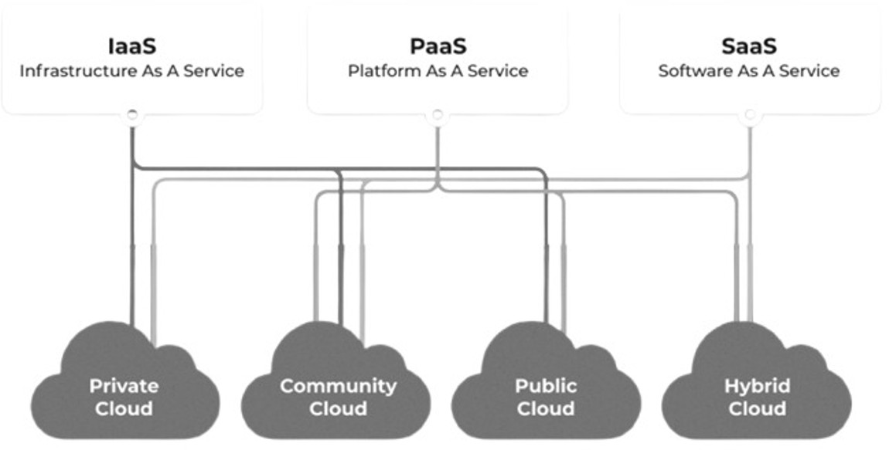

Fig. 1. Cloud Service Models

* 1. **Public Cloud:** In a public cloud model, cloud resources are owned and operated by third-party cloud providers and are made available to multiple customers over the internet [11]. This model offers cost-effective access to high-performance comput- ing, storage, and applications without the need for organizations to invest in their own hardware. Public clouds operate on a pay-as-you-go basis, making them attractive to businesses seeking to avoid up- front capital expenditures. Public clouds are highly scalable and flexible, with examples including Ama- zon Web Services (AWS), Microsoft Azure, and Google Cloud Platform (GCP) [2]. However, as public clouds are shared environments, they may offer less customization and control compared to private cloud options.
  2. **Private Cloud:** A private cloud is a cloud environ- ment dedicated to a single organization, providing greater control, privacy, and security. Private clouds can be hosted on-premises or managed by a third- party provider, and they are tailored to meet the organization’s specific requirements [5]. This model is ideal for organizations with strict regulatory or se- curity needs, such as financial institutions or govern- ment agencies. Private clouds allow organizations to maintain control over their data and customize their infrastructure. While they offer increased security and compliance capabilities, private clouds typically involve higher costs and require more resources to manage than public cloud environments.
  3. **Community Cloud:** Also known as an organiza- tional or industry cloud, a community cloud model is designed for use by multiple organizations that share common goals, policies, or compliance re- quirements. This model allows organizations within a specific industry—such as healthcare, education, or government—to collaborate and share resources within a secure environment [3]. Community clouds are typically hosted and managed by a third-party provider or jointly managed by the participating organizations. They provide the benefit of a shared infrastructure while maintaining specific access con- trols and compliance standards required by the com-

munity.

* 1. **Hybrid Cloud:** The hybrid cloud model combines public and private cloud environments, allowing data and applications to be shared between them [1]. This model provides the flexibility to run general workloads in the public cloud while keeping sen- sitive data and critical applications in the private cloud, balancing security with scalability. Hybrid clouds enable organizations to leverage the best aspects of both public and private clouds, support- ing seamless integration and data transfer between environments. For instance, organizations might use the public cloud for high-volume, low-security tasks while keeping sensitive workloads in their private cloud [14]. Hybrid clouds are particularly valuable for organizations that need to optimize performance, cost, and security, as they can dynamically manage workloads across different environments.

This overview of cloud computing models highlights the different levels of service and deployment options available, enabling organizations to choose solutions that align with their business needs, security requirements, and budget constraints.

1. Serverless Computing and Cold Start

Problem

1. *Serverless Architecture*

Serverless computing represents a transformative shift in cloud computing paradigms, enabling developers to focus primarily on writing application code rather than managing the underlying infrastructure [9]. This model leverages the concept of *Function as a Service (FaaS)*, where applications are composed of discrete functions that execute in response to specific events or triggers. Serverless platforms, such as AWS Lambda, Azure Func- tions, and Google Cloud Functions, autonomously handle the complexities of infrastructure management, including resource provisioning, scaling, and maintenance, allowing developers to concentrate on application logic [10].

**Characteristics of Serverless Computing** include:

* + **Small and Temporary Functions:** Functions are inherently ephemeral, executing only when triggered

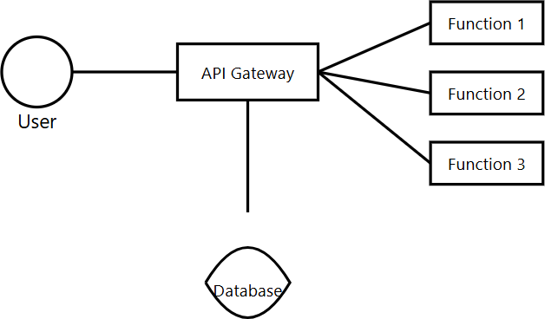

Fig. 2. serverless computing

by specific events and relinquishing resources im- mediately after completion [6]. This statelessness contrasts with traditional computing models, where persistent applications may occupy resources contin- uously, regardless of demand.

* **Stateless Execution:** Each function operates inde- pendently and retains no state between invocations. This stateless nature simplifies scalability, as func- tions can be executed concurrently without concerns about shared state or data consistency [7].
* **Event-Driven Architecture:** Functions are invoked in response to events, which can include a variety of triggers such as HTTP requests, changes in database records, or messages from IoT devices. This event- driven approach allows applications to respond dy- namically to real-time data and user interactions [8].

**Execution Process:** Serverless functions run within lightweight, isolated containers, which provide a secure environment for execution. When a function is invoked, a new container is created (or a warm container is reused), and concurrent invocations are handled in separate con- tainers to enhance performance and isolation. The execu- tion process typically unfolds as follows:

1. **Container Initialization:** Upon invocation, the serverless platform configures the environment by setting up environment variables, establishing con- nections to necessary services (like databases), and handling user authentication [9]. This initialization step is crucial for preparing the function to execute successfully.
2. **Resource Allocation:** The platform dynamically allocates resources, including memory and CPU, based on the function’s requirements. This elasticity enables optimal performance, as resources can be scaled up or down depending on demand.
3. **Function Execution:** The serverless function pro- cesses the incoming request, performing the neces- sary computations and operations [14]. This execu- tion can involve accessing external APIs, querying databases, or executing business logic as defined by the developer.
4. **Result Return:** After processing, the function re- turns the result to the caller and logs execution details, such as the duration, memory usage, and any errors encountered. These logs are valuable for

monitoring and optimizing function performance.

1. *Cold Start Issue in Serverless Computing*

One of the most significant challenges facing serverless computing is the *cold start* problem. This issue arises when a serverless function is invoked after a period of inactivity, necessitating the creation and initialization of a new container [1]. Cold starts can introduce latency that varies based on several factors, including the function’s complexity, the presence of external dependencies (like libraries or services), and the cloud environment’s opera- tional conditions.

Cold starts can adversely affect user experience, partic- ularly for latency-sensitive applications, such as real-time data processing or IoT systems. To mitigate the impact of cold starts, some platforms employ strategies to keep func- tions in a ”warm state” after execution, preserving runtime environments to reduce initialization times [11]. However, this approach can lead to resource waste, especially when functions remain idle for extended periods.

In summary, addressing cold start delays is critical for optimizing serverless applications, improving resource efficiency, and ensuring a reliable user experience in high- demand environments.

1. Related Works
2. *Traditional Cold Start Mitigation Techniques*

To address the challenges posed by cold starts in server- less computing, various traditional techniques have been developed [2]. A common approach is *container pooling*, where a pool of pre-warmed containers is maintained to reduce initialization time. In this strategy, platforms like AWS Lambda, Google Cloud Functions, and Microsoft Azure aim to reuse halted containers for subsequent re- quests within a designated idle-container time window. By retaining these containers in a ready state, the frequency of cold starts is significantly reduced, leading to improved response times for users and a more efficient allocation of resources.

Another prevalent technique is *pre-warming*, which involves keeping containers in a “warm state” for a spec- ified duration after execution [12]. This approach ensures that runtime environments and loaded libraries remain intact, facilitating faster subsequent invocations. While this

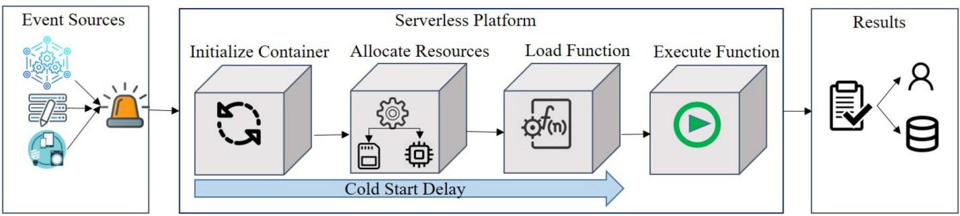

Fig. 3. Cold start delay

method effectively mitigates cold start delays, it can lead to unnecessary memory consumption if containers remain idle for extended periods. AWS Lambda’s provisioned concurrency feature exemplifies this strategy, allowing de- velopers to specify the number of pre-warmed containers that should be maintained for upcoming requests [4]. This feature helps to balance the trade-off between minimizing cold start occurrences and optimizing resource usage, thus providing a more tailored serverless experience.

Additionally, techniques such as *prebaking* and *warm template queue containers* have emerged as effective strategies for cold start mitigation. Prebaking involves capturing container snapshots before function execution, which can significantly accelerate the startup time dur- ing subsequent invocations [3]. This technique is par- ticularly beneficial in scenarios where functions have large dependencies or complex initialization processes. On the other hand, warm template queue containers—used in models like the Warm Load Execution Context (WLEC)—maintain copies of warm containers in a queue, allowing for rapid function execution upon demand. This ensures that when a function is called, the necessary environment is already prepared, further reducing cold start latencies [1].

1. *Advances in Machine Learning for Cold Start Mitiga- tion*

Recent advancements in machine learning (ML) have paved the way for dynamic, predictive approaches to mitigating cold starts in serverless computing. These tech- niques leverage historical invocation data and patterns to optimize resource allocation and reduce initialization times. One notable approach involves the use of *Long Short-Term Memory (LSTM)* models, which are capable of learning temporal dependencies in sequential data [7]. By applying LSTM models to predict future invocation patterns, serverless platforms can adaptively pre-warm containers based on anticipated demand. For instance, research by Xu et al. has demonstrated how LSTM models can be utilized to forecast workload patterns, thereby enabling more efficient resource management. By pre- launching containers before predicted spikes in demand, these platforms can effectively minimize the adverse im- pacts of cold starts.

Further innovations in this domain include the applica- tion of *reinforcement learning* (RL) models, which offer

a more dynamic and responsive approach to resource management [8]. Agarwal et al. have explored the use of Q-learning algorithms to dynamically scale function instances in real-time, responding to fluctuating resource requirements and varying request patterns. This adaptabil- ity allows for better handling of workloads that exhibit unpredictable spikes or drops in demand, improving over- all system performance.

Additionally, researchers have developed the Hybrid Histogram Policy, which optimizes the idle-container time window based on the specific characteristics of individual functions [3]. This policy aims to minimize cold start de- lays while also reducing resource wastage by intelligently managing how long containers should remain warm based on anticipated usage patterns.

Deep reinforcement learning has also emerged as a promising solution to the cold start problem due to its ability to adapt in real-time to continuous state changes within cloud environments. Such models can provide improved scalability by constantly optimizing container management strategies, making them particularly well- suited for dynamic workloads characterized by fluctuating demands [14]. The incorporation of deep reinforcement learning techniques into serverless architectures has the potential to further enhance performance, allowing for real-time adjustments that align resource allocation with actual usage patterns.

In summary, the integration of machine learning tech- niques into cold start mitigation strategies represents a significant advancement in serverless computing, offering robust solutions that improve efficiency, scalability, and user experience [8]. As these technologies continue to evolve, they promise to further enhance the capabilities and reliability of serverless platforms.

1. Proposed Adaptive Approach

This section introduces a two-layer adaptive framework designed to mitigate cold start latency in serverless envi- ronments. This innovative framework combines machine learning-based prediction models with advanced resource management techniques [6], aiming to reduce both the frequency and delay of cold starts effectively.

* 1. *Layer 1: Cold Start Frequency Reduction*

The first layer of the proposed framework focuses on minimizing the frequency of cold starts by dynamically

adjusting the idle-container window based on usage pat- terns. This layer consists of several crucial steps:

* + 1. **Invocation Pattern Extraction:** This initial step involves the detailed analysis of serverless function logs to identify distinct patterns in usage and periods of inactivity. By examining the historical invocation data [11], the system can determine the typical in- tervals between invocations and pinpoint the specific periods that tend to lead to cold starts. This analysis is essential for understanding user behavior and optimizing resource allocation.
    2. **Deep Neural Network Prediction:** Utilizing a deep neural network trained on the historical invocation data, this step aims to predict the optimal idle- container window for each function [13]. The model considers various factors, including the frequency and timing of previous invocations, to ensure that containers are maintained in a warm state only when necessary. This approach balances the need for quick responses with efficient resource consumption, thereby enhancing overall system performance.
    3. **Error Minimization:** To quantify the trade-off be- tween cold start occurrences and resource usage, an error function is defined as follows:

Error = *fc* + *R*

*Ti c*

In this equation, *fc* represents the frequency of cold starts, *Ti* is the total number of invocations over a defined period, and *Rc* denotes the resource consumption during that same timeframe. By min- imizing this error function, the framework seeks to achieve an optimal balance between reducing cold starts and managing resource usage efficiently.

* + 1. **Update Configuration:** Based on the predictions generated by the deep neural network, the idle- container window is dynamically updated within the serverless platform’s configuration settings. This continuous adjustment ensures that the system main- tains the optimal balance between performance effi- ciency and cost-effectiveness, adapting to changing usage patterns over time.
  1. *Layer 2: Cold Start Delay Reduction*

The second layer of the adaptive framework focuses on minimizing delays associated with requests that encounter cold starts [2], particularly during periods of high demand or simultaneous invocations:

* + 1. **Concurrent Invocation Prediction:** In this step, Long Short-Term Memory (LSTM) models are em- ployed to predict the number of concurrent invo- cations that a serverless function may experience. By analyzing historical invocation data, the LSTM model anticipates demand spikes and adjusts re- source allocation proactively [3]. This predictive capability is vital for ensuring that the system can meet user demand without incurring significant cold start delays.
    2. **Pre-warmed Container Allocation:** Based on the predictions of concurrent invocations, the system

allocates pre-warmed containers to facilitate rapid resource availability. By ensuring that enough con- tainers are warm and ready to handle incoming requests, this step significantly reduces cold start times, enhancing user experience and application performance during peak usage [1].

* + 1. **Dynamic Resource Allocation:** Continuous moni- toring of resource usage allows the system to dy- namically adjust warm container allocations in real- time. By responding to changing demand patterns, the system enhances resource efficiency and further reduces the likelihood of cold start delays [14]. This dynamic approach ensures that resources are allocated optimally, preventing over-provisioning or under-utilization.
  1. *Model Formulation and Error Minimization*

The proposed adaptive approach incorporates a mathe- matical model designed to optimize the reward function for effective resource allocation:

* **Reward Function:** To evaluate the effectiveness of resource allocation strategies, the reward function is defined as follows:

Reward = *−* Cold + *P*

*N*

In this formula, *Cold* signifies the number of cold starts that occur, *N* represents the total number of invocations within the same period, and *P* is a penalty factor that accounts for memory wastage [8]. By incentivizing the minimization of cold starts while ensuring efficient resource usage, this reward function guides the adaptive framework in optimizing overall performance.

* **Error Minimization and Parameter Update:** The model continuously refines its parameters to mini- mize errors associated with resource allocation. This refinement process involves updating configurations based on real-time data collected from the serverless environment. The goal is to minimize the balance between resource waste and cost, ensuring that the system operates efficiently while maintaining a high level of responsiveness.

In summary, this adaptive framework provides a robust solution to the cold start challenges commonly faced in serverless computing environments. By optimizing re- source usage and minimizing response times, this ap- proach not only enhances the performance of serverless applications but also ensures a reliable user experience, even during periods of fluctuating demand. The integra- tion of machine learning techniques allows for intelligent decision-making, positioning this framework as a signifi- cant advancement in serverless architecture.

* 1. *Integration of Explainable AI (XAI) in Adaptive Frame- work*

The integration of Explainable AI (XAI) within the pro- posed adaptive framework enhances transparency and in- terpretability in resource management decisions for server- less computing. XAI techniques, specifically the Local In- terpretable Model-agnostic Explanations (LIME) method,

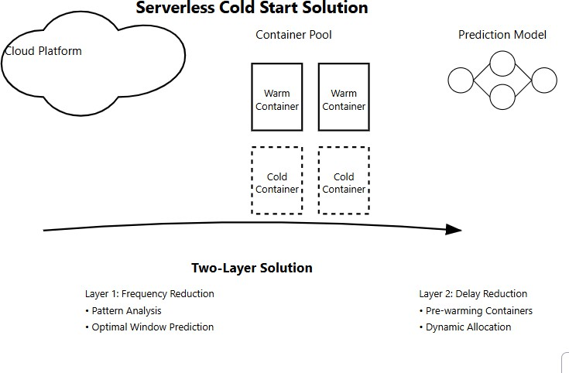

are employed to ensure that machine learning predictions and resource allocation strategies are understandable and trustworthy, particularly for high-stakes, latency-sensitive applications.

* + 1. **Enhancing Model Interpretability with LIME:** To explain the outputs of complex models (such as deep neural networks and LSTMs), LIME is used to create simplified, interpretable models that approximate the behavior of the predictive model on individual predictions. By applying LIME, stake- holders can understand the factors that influence spe- cific resource allocation decisions or pre-warming predictions, such as invocation patterns, memory usage, and function complexity.
    2. **Transparent Resource Allocation Decisions:** XAI provides insights into the factors that influence the adaptive framework’s decisions, including the idle- container window and concurrent invocation pre- dictions. By using LIME, the model highlights the most influential features, such as expected invoca- tion frequency and resource consumption, that lead to specific resource management adjustments. This transparency builds trust, especially in scenarios where resource allocation impacts application per- formance directly.
    3. **Improved Trust in High-Demand Scenarios:** In cases of demand surges or concurrent invocation spikes, LIME enables real-time interpretability by providing explanations for why the model recom- mends specific adjustments. These explanations are particularly valuable in applications requiring strict performance standards, like financial transactions or healthcare monitoring, where understanding model- driven decisions is crucial.
    4. **Supporting Continuous Model Refinement:** The insights from LIME can also guide continuous model refinement. By observing the explanations generated by LIME over time, the adaptive frame- work can identify patterns that may lead to inaccura- cies in resource management. Feedback from LIME explanations helps in refining model parameters, thus ensuring that the adaptive framework remains aligned with evolving demand and invocation pat- terns.

The integration of LIME within the XAI-enabled adap- tive framework provides an explainable, trust-building

layer that supports the predictive and dynamic resource management processes. This approach strengthens perfor- mance optimization and enhances system accountability, user confidence, and overall system reliability.

1. Evaluation and Experimental Setup

This section outlines the experimental design and eval- uation methodology used to assess the performance of the proposed adaptive model for mitigating cold start latency in serverless environments. It includes a detailed descrip- tion of the experimental setup, the metrics employed for evaluation, and an analysis of the results obtained.

1. *Experimental Design*

The experiments were meticulously conducted using a diverse set of real-world serverless applications deployed across multiple serverless platforms, including Amazon Web Services (AWS) Lambda, Microsoft Azure Func- tions, and Apache OpenWhisk. This multi-platform ap- proach was adopted to ensure a comprehensive and robust comparison of the adaptive model’s performance across varying cloud environments and configurations.

Each platform was configured with identical parameters, such as memory allocation, execution timeout, and concur- rency limits, to guarantee fairness in the comparison and isolate the effects of the adaptive model on performance. By standardizing these parameters, we aimed to create a level playing field that accurately reflects the impact of the adaptive techniques without being confounded by platform-specific differences.

The dataset utilized for evaluation comprised four dis- tinct serverless applications, each characterized by unique computational requirements and resource utilization pat- terns. Table I presents a summary of these applications, highlighting the number of functions, along with their cor- responding cold-start and warm-start execution times. This detailed logging enabled comprehensive data collection, which facilitated an in-depth performance analysis and comparison between the adaptive model and traditional cold-start mitigation strategies.

1. *Performance Metrics*

To evaluate the effectiveness of the adaptive model, we analyzed several key performance metrics that directly re- flect the system’s performance in terms of responsiveness and efficiency:

TABLE I

Serverless Applications Used for Evaluation

|  |  |  |  |  |
| --- | --- | --- | --- | --- |
| **Application** | **Function Count** | **Cold-Start Time (ms)** | **Warm-Start Time (ms)** | **Invocation Count** |
| Email Processing | 5 | 1200 | 200 | 5000 |
| Image Processing | 10 | 1500 | 300 | 7000 |
| Data Analysis | 8 | 1300 | 250 | 4500 |
| Video Transcoding | 6 | 1600 | 350 | 3000 |

* + **Response Time:** This metric measures the average time taken to execute each function, expressed in milliseconds. A reduction in response time is in- dicative of improved efficiency in request processing, reflecting how quickly the system can respond to user invocations.
  + **Cold-Start Delay:** This metric refers to the additional time incurred when a function is invoked after a period of inactivity. It is calculated as the difference between cold-start and warm-start execution times. Monitoring cold-start delay provides insights into the model’s effectiveness in reducing initialization overhead, which is critical for latency-sensitive ap- plications.
  + **Frequency of Cold Starts:** This quantifies the num- ber of cold start occurrences within a specific time- frame. A lower frequency of cold starts indicates bet- ter container management and contributes to enhanc- ing overall system performance and user experience. This metric is particularly important for assessing the economic efficiency of the adaptive approach, as it correlates with reduced resource overhead.

1. *Results and Analysis*

The evaluation results, summarized in Figures 4 and 5, illustrate the significant performance improvements achieved by the adaptive model compared to traditional cold-start mitigation techniques:

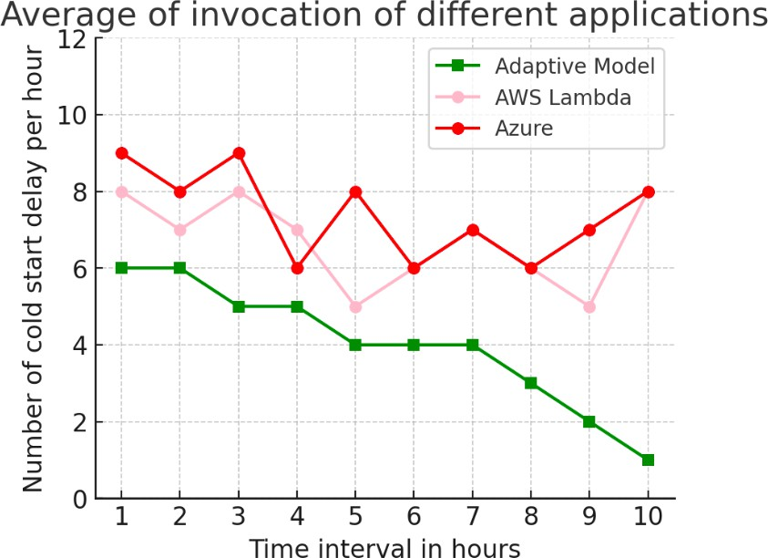

Fig. 4. Cold Start Delay Reduction

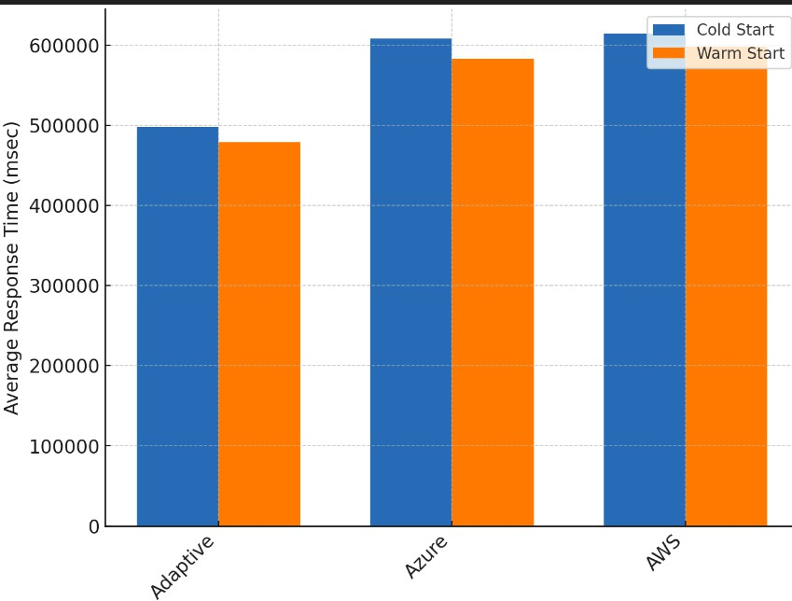

Fig. 5. Average Response Time Analysis

* + **Response Time Analysis:** As depicted in Figure 5, the adaptive model demonstrated a remarkable reduction in average response times across all appli- cations, achieving an approximately 30% decrease. This improvement can be attributed to the model’s predictive capability, which enables it to pre-warm containers based on historical invocation patterns. By anticipating when functions are likely to be invoked, the model minimizes cold-start initialization time, thereby enhancing overall system responsiveness.
  + **Cold-Start Delay Reduction:** Figure 4 illustrates that the adaptive model successfully decreased cold- start delays by an average of 40% across the eval- uated applications. This significant reduction re- sults from the adaptive management of containers, which anticipates periods of inactivity and adjusts pre-warmed container allocations accordingly. Such proactive management minimizes the cold-start im- pact on latency-sensitive applications, ensuring that users experience reduced wait times.
  + **Frequency of Cold Starts:** The results indicate that the adaptive model effectively reduced the frequency of cold starts by up to 50%. This reduction implies greater efficiency in resource utilization and an im- proved user experience, as fewer instances of cold starts lead to smoother operation. Additionally, this decrease in cold starts can yield potential cost savings for service providers, as it reduces the number of

containers that need to be allocated and maintained, thereby minimizing resource overhead.

In conclusion, the results indicate that the proposed adaptive model not only enhances performance by re- ducing response times and cold-start delays but also contributes to more efficient resource utilization, which is crucial for the scalability and economic viability of serverless architectures. These findings suggest that inte- grating adaptive mechanisms based on machine learning can significantly improve the user experience in serverless environments, making them more responsive and cost- effective.

1. Discussion

In this section, we discuss the implications of our findings, interpreting the results of our evaluation and exploring how the proposed adaptive model can be applied in real-world scenarios.

1. *Interpretation of Results*

The evaluation results demonstrate a clear advantage of the proposed adaptive model over traditional cold start mit- igation techniques across several key performance metrics, notably response time, cold-start delay, and frequency of cold starts. By employing machine learning algorithms to analyze historical invocation data, our model effectively predicts invocation patterns, enabling it to dynamically adjust the readiness of serverless containers in anticipation of incoming requests.

This predictive capability is critical in reducing cold start latency. Traditional methods often rely on static pre-warming strategies, which may lead to either over- provisioning or under-provisioning of resources. In con- trast, our adaptive model optimizes container availability by dynamically managing their states, ensuring that func- tions are ready to respond to requests with minimal delay. This adaptability not only enhances the system’s overall efficiency but also results in improved user satisfaction due to faster response times.

Moreover, the reduction in cold start frequency is partic- ularly noteworthy. A lower frequency of cold starts implies that fewer containers need to be unnecessarily warmed up, leading to significant operational cost savings. This optimization of resource allocation is especially beneficial in serverless architectures, where billing is often based on resource utilization. By minimizing the need for container warming, the adaptive model aligns well with the eco- nomic incentives of serverless computing, allowing orga- nizations to achieve better performance without incurring excessive costs.

1. *Implications for Real-World Applications*

The implications of the adaptive model’s ability to mini- mize cold start delays are profound, especially for latency- sensitive applications that demand high responsiveness and reliability. In fields such as real-time data processing for Internet of Things (IoT) systems and financial transactions, even minor delays can have significant repercussions. For instance, in financial applications, delays in transaction

processing can lead to financial losses or affect user trust. By implementing our adaptive model, organizations can ensure that their applications maintain low-latency performance even during peak usage periods.

Furthermore, the scalability of the adaptive model makes it particularly suitable for diverse use cases across various industries. As businesses increasingly migrate to cloud-native architectures, maintaining high performance during fluctuating demand becomes crucial. The model’s proactive management of container states based on an- ticipated usage patterns allows serverless platforms to effectively handle dynamic workloads without sacrific- ing performance. This capability is especially relevant in scenarios characterized by unpredictable spikes in traffic, where traditional cold start mitigation techniques may struggle to keep up.

Additionally, the adaptive model can be integrated with other performance optimization strategies, such as load balancing and auto-scaling, to further enhance application responsiveness. By collaborating with these mechanisms, the model can create a holistic approach to resource man- agement that maximizes efficiency and minimizes latency across serverless environments.

In conclusion, the adaptive model presented in this study not only addresses the critical issue of cold start latency in serverless computing but also opens up new avenues for enhancing application performance in real- world scenarios. By leveraging machine learning to opti- mize container readiness, organizations can improve user experiences, reduce operational costs, and maintain high performance in an increasingly cloud-centric landscape. The findings of this study provide a compelling case for the adoption of adaptive strategies in the design and implementation of serverless applications, paving the way for more responsive and efficient cloud services.

1. Conclusion

This study presents a novel adaptive model designed to address the cold start problem prevalent in serverless computing environments. The proposed model leverages machine learning techniques to analyze historical func- tion invocation patterns, enabling it to predict periods of inactivity and dynamically manage container states. This innovative approach results in significant enhancements in key performance metrics, including response time, cold start delay, and overall operational efficiency.

Experimental results demonstrate the efficacy of the adaptive model, revealing that it reduces the frequency of cold starts by up to 50% while simultaneously decreasing cold start delays by an average of 40%. These substantial improvements underscore the model’s superiority over conventional cold start mitigation strategies, which often rely on static pre-warming or resource allocation methods that fail to adapt to real-time demand fluctuations. The ability to dynamically adjust container readiness not only enhances application responsiveness but also contributes to cost savings by optimizing resource utilization in server- less architectures.

However, despite the notable successes achieved by the adaptive model, certain limitations must be acknowledged.

One key challenge is the model’s dependence on the availability of comprehensive historical data for accurate predictions. In scenarios where historical data is sparse or not representative of future usage patterns, the predictive accuracy of the model may diminish, potentially leading to suboptimal container management. Therefore, careful data collection and preprocessing are essential to ensure that the model can function effectively.

Additionally, the adaptive model may require tuning and adjustments to maintain its performance across different serverless platforms, as variations in architecture, resource allocation policies, and workload characteristics can in- fluence the effectiveness of the model. Future research should focus on developing strategies for automated tuning and cross-platform adaptability to enhance the model’s robustness.

Looking ahead, there are several avenues for further improvement and exploration. Integrating security con- siderations into the adaptive model is a critical area for future work, particularly as security concerns continue to grow in importance within cloud computing environments. Exploring mechanisms to ensure data privacy and integrity while optimizing for performance will be essential for widespread adoption.

Moreover, adapting the model for environments where cold start impacts are particularly severe, such as in highly latency-sensitive applications, could significantly expand its applicability. This could involve the incorporation of additional context-aware features that capture real-time traffic patterns and user behaviors to refine predictions and enhance responsiveness even further.

In conclusion, the adaptive model introduced in this study provides a promising solution to the cold start problem in serverless computing. By effectively utilizing machine learning to optimize container readiness, the model not only enhances application performance and user experience but also presents a scalable approach to resource management in cloud-native environments. As organizations continue to embrace serverless architectures, the insights and findings of this study contribute valuable knowledge towards improving the efficiency and reliability of serverless applications.

1. Future Directions
2. *Advanced Model Optimizations*

Future research should focus on refining the predictive algorithms to further improve the accuracy of cold start predictions. Incorporating additional data sources, such as user activity trends or environmental conditions, could enhance the model’s ability to anticipate demand surges. Machine learning approaches such as ensemble learning or reinforcement learning could be explored to create more adaptive and responsive container management strategies that can self-tune in real-time.

1. *Broader Application Scenarios*

Beyond traditional serverless environments, the pro- posed model has potential applications in edge computing and IoT, where cold start latency can have a signifi- cant impact on user experience. By optimizing container

readiness at the network edge, this model could support faster responses for latency-sensitive services, such as autonomous vehicle coordination or smart city infras- tructure. Additionally, the model could be adapted to manage resources in hybrid cloud setups, where workload distribution between cloud and edge environments requires seamless coordination to meet application.

References

1. Siddharth Agarwal, Maria A. Rodriguez, and Rajkumar Buyya. A reinforcement learning approach to reduce serverless function cold start frequency, 2021. <http://clouds.cis.unimelb.edu.au/papers/RL-> ServerlessFunction-CCGrid2021.pdfLink.
2. Mahfooz Alam, Suhel Mustajab, Mohammad Shahid, and Faisal Ahmad. Cloud computing: Architecture, vision, challenges, opportunities, and emerging trends. In *2023 International Conference on Computing, Communication, and Intelligent Systems (ICCCIS)*, pages 829–834, 2023. https://ieeexplore.ieee.org/document/9687209Link.
3. Ta Phuong Bac, Minh Ngoc Tran, and YoungHan Kim. Serverless computing approach for deploying machine learning applications in edge layer, 2022. https://ieeexplore.ieee.org/document/9687209Link.
4. Dev Baloni, Chandradeep Bhatt, Satender Kumar, Pritesh Pa- tel, and Teekam Singh. The evolution of virtualization and cloud computing in the modern computer era, 2023. https://ieeexplore.ieee.org/document/10421611Link.
5. Thu Yein Htet, Thanda Shwe, Israel Mendonca, and Masayoshi Aritsugi. Pre-warming: Alleviating cold start occurrences on cloud-based serverless platforms, 2024. https://ieeexplore.ieee.org/document/10629113?denied=Link.
6. Kumari, Bibhudatta Sahoo, and Ranjan Behera. Mitigating cold- start delay using warm-start containers in serverless platform, 11 2022. https://ieeexplore.ieee.org/document/9687209Link.
7. Xuanzhe Liu, Jinfeng Wen, Zhenpeng Chen, Ding Li, Junkai Chen, Yi Liu, Haoyu Wang, and Xin Jin. Faaslight: General application-level cold-start latency optimization for function-as-a-service in serverless computing, 2023. https://dl.acm.org/doi/10.1145/3585007Link.
8. Manish Pandey and Young-Woo Kwon. Funcmem: Reducing cold start latency in serverless computing through memory prediction and adaptive task execution, 2024. https://dl.acm.org/doi/10.1145/3605098.3636033Link.
9. Maristella Ribas, Alberto Sampaio Lima, Jose Neuman de Souza, Flavio Rubens de Carvalho Sousa, and Leonardo Oliveira Moreira. A platform as a service billing model for cloud computing management approaches, 2016. https://ieeexplore.ieee.org/document/9687209Link.
10. Ravi Seethamraju. Adoption of saas enterprise systems

— a comparison of indian and australian smes, 2014. https://ieeexplore.ieee.org/document/9687209Link.

1. Parichehr Vahidinia, Bahar Farahani, and Fereidoon Shams Aliee. Mitigating cold start problem in serverless computing: A reinforcement learning approach. *IEEE Internet of Things Journal*, 10(5):3917–3927, 2023. https://ieeexplore.ieee.org/document/9749611Link.
2. Joe Weinman. The future of cloud computing. In *2011 IEEE Technology Time Machine Symposium on Technologies Beyond 2020*, pages 1–2, 2011. https://ieeexplore.ieee.org/document/6005157?denied=Link.
3. Amelie Chi Zhou, Rongzheng Huang, Zhoubin Ke, Yusen Li, Yi Wang, and Rui Mao. Tackling cold start in serverless computing with multi-level container reuse, 2024. https://scholars.hkbu.edu.hk/en/publications/tackling-cold-start-in- serverless-computing-with-multi-level-contLink.
4. Yu Chen Zhou, Xin Peng Liu, Xi Ning Wang, Liang Xue, Xiao Xing Liang, and Shuang Liang. Business process centric platform-as-a-service model and technologies for cloud enabled industry solutions, 2010. https://ieeexplore.ieee.org/document/9687209Link.